**LAB #2**

**Objective:** Exploring EaseUs Data Recovery Tool and R-Drive Image Tool .

**TASKS:**

1) Download R-Drive Image Tool and explore it by creating image of any disk file:  
  
i) Open R-Drive Image Tool and go to Create image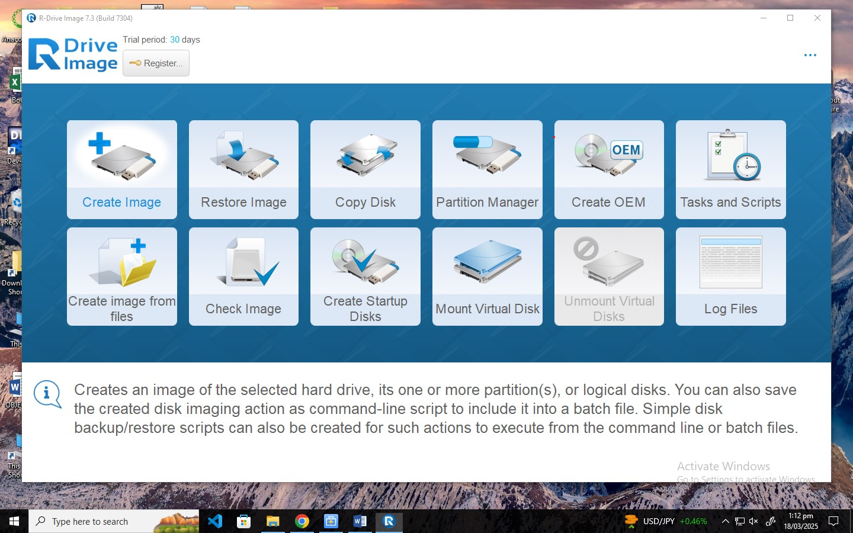

ii) Select disk to create image from  
I choose E disk  
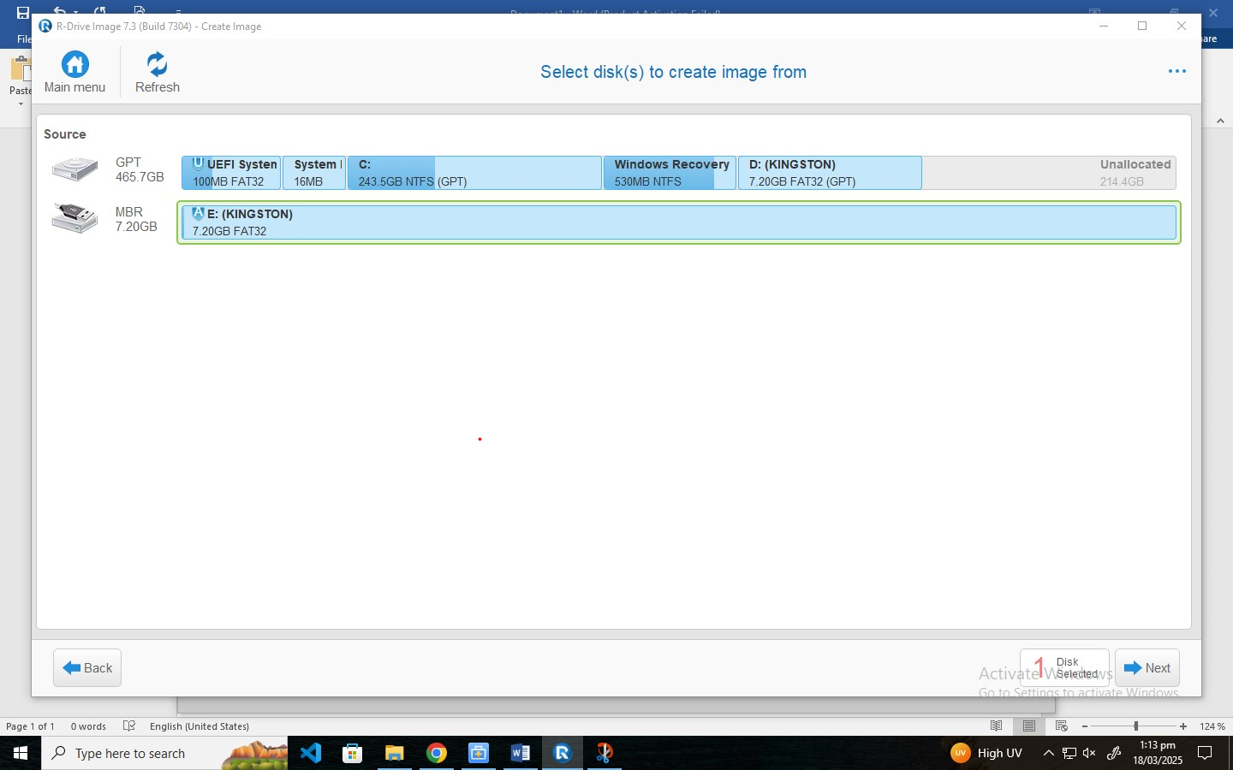

iii) Select destination for new image, and press Next  
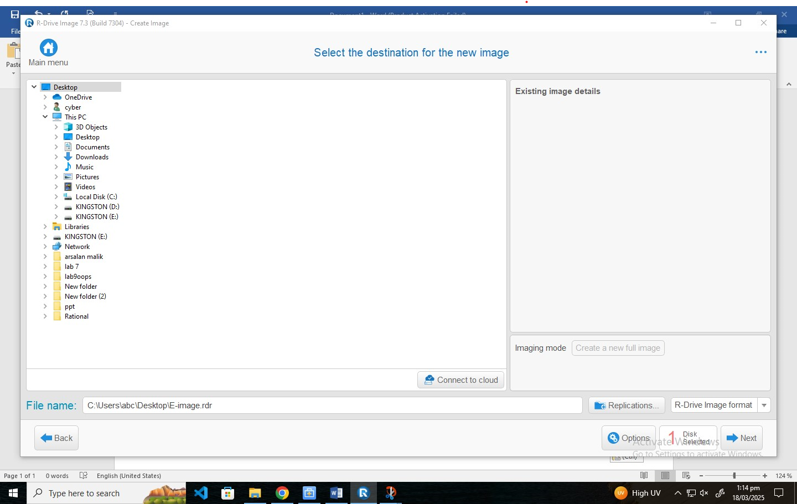   
iv) Showing total operations list to be done, press Start  
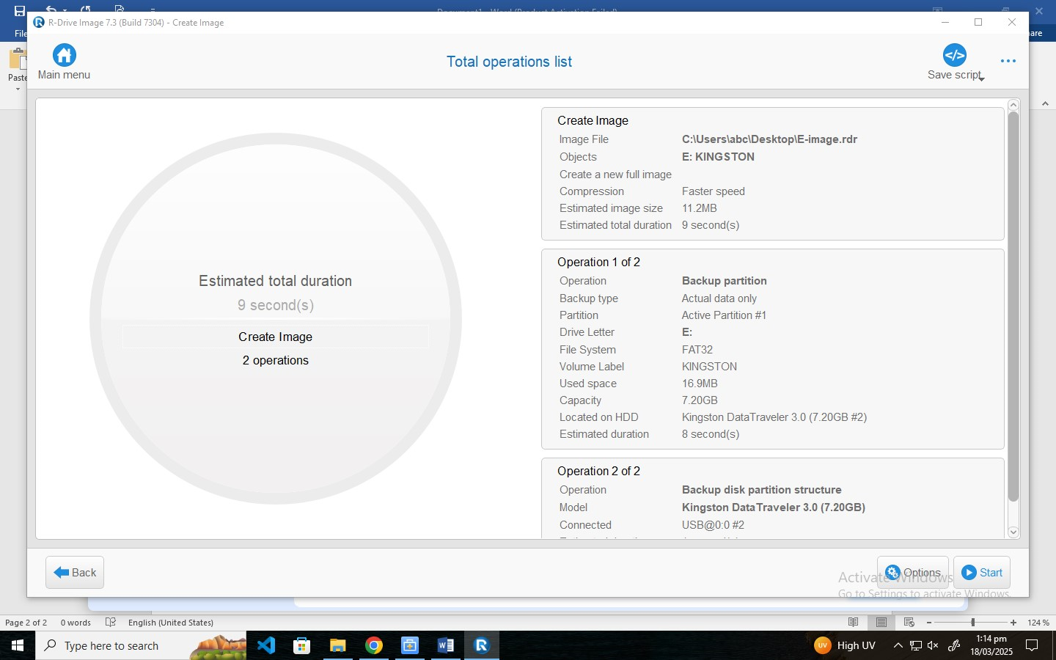  
v) Showing total execution completion  
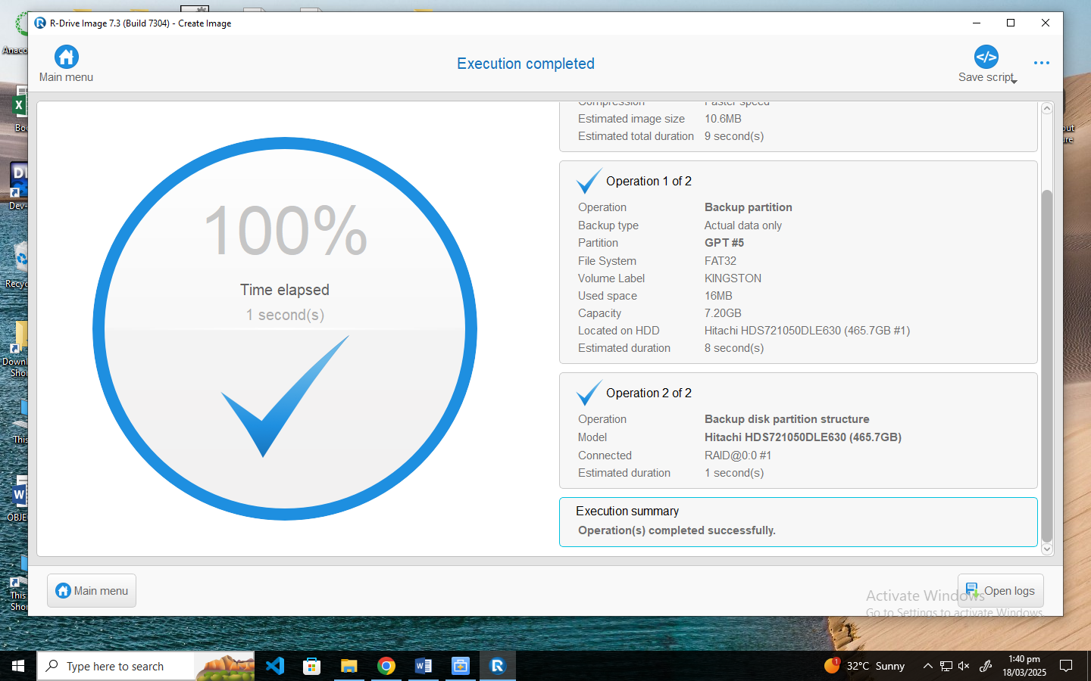

vi) Image is created successfully

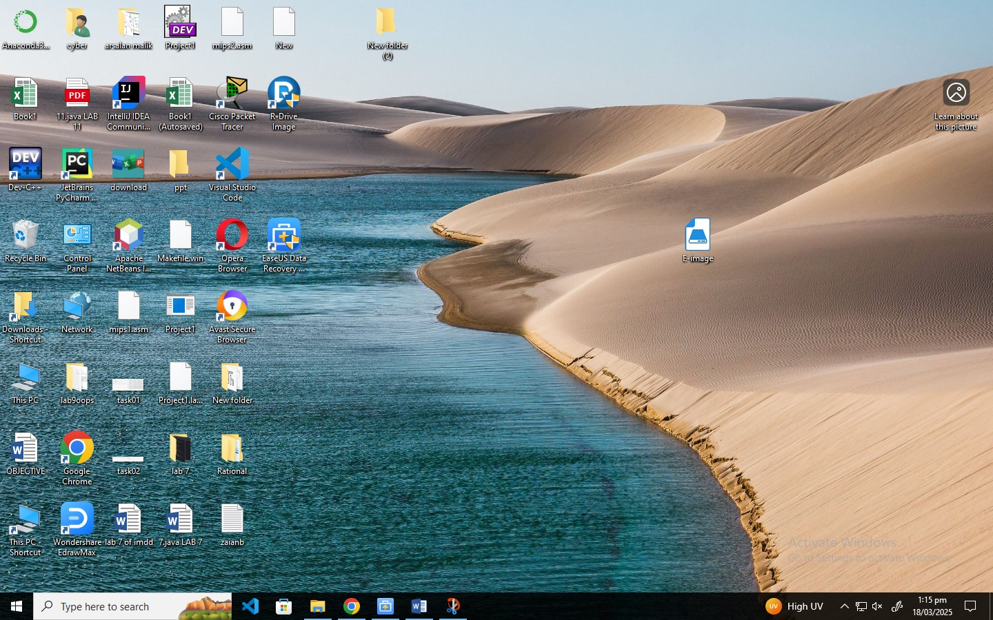

2)Download and explore EaseUs Data Recovery Tool:

i) Select location for searching of lost data which need to be restore

I choose Recycle Bin here

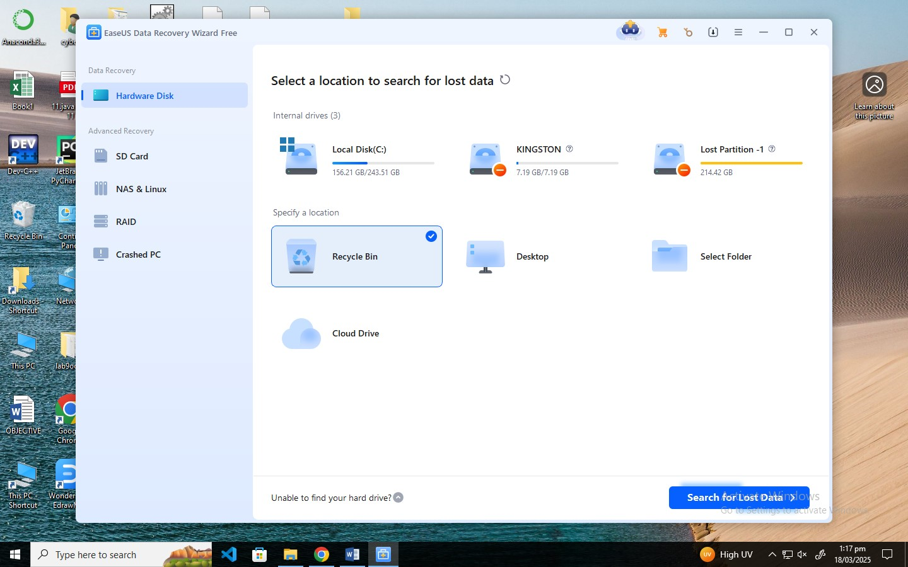  
  
  
  
  
  
  
  
  
  
ii) Select data that need to be restore and press Recover All  
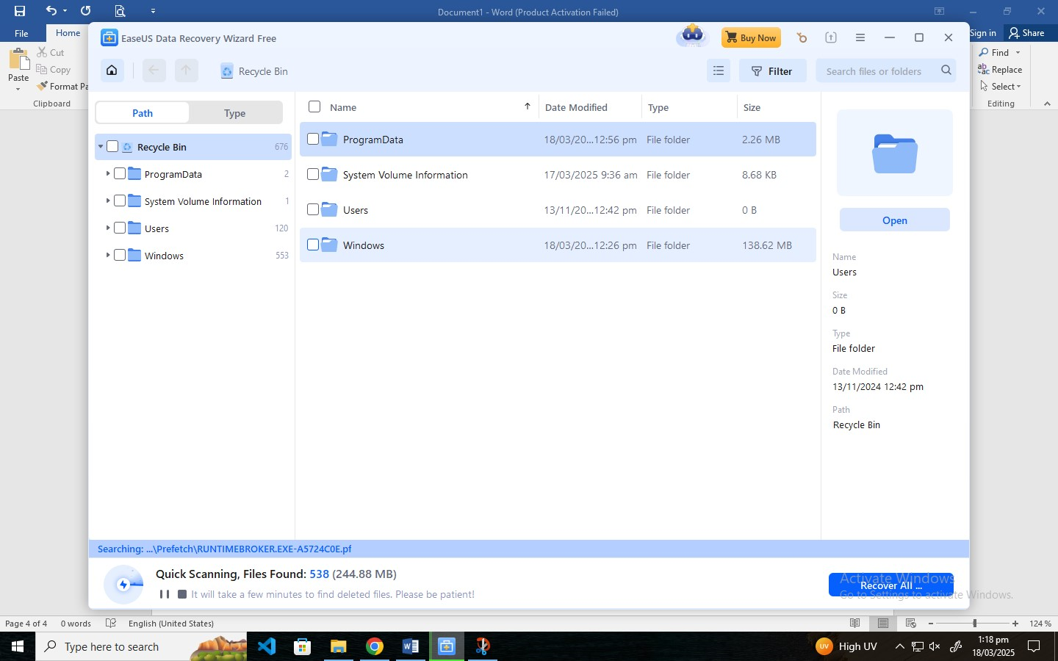  
It will recover your lost data.  
  
 **Recovering whole Disk**

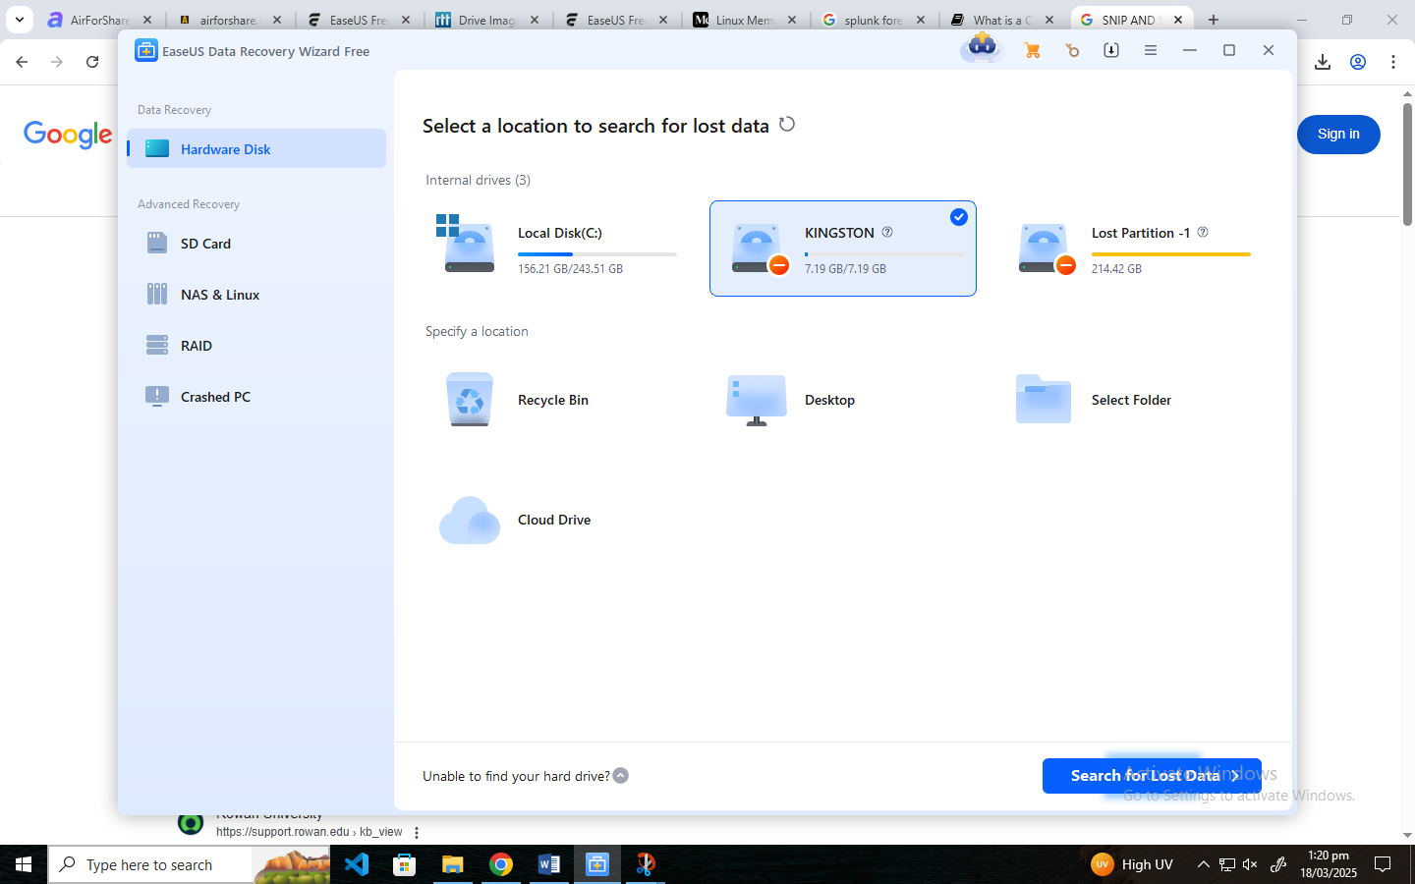  
  
  
  
Scan Completed, means Disk is recovered  
